**Shetran Easy Setup**

**See video at** [**https://youtu.be/zYrDnVq5iD8**](https://youtu.be/zYrDnVq5iD8)

1. **Go to folder “examples/Aire_at_Kildwick_Bridge”**

There are three sorts of files: xml (library) file, ASCII grids, time series data

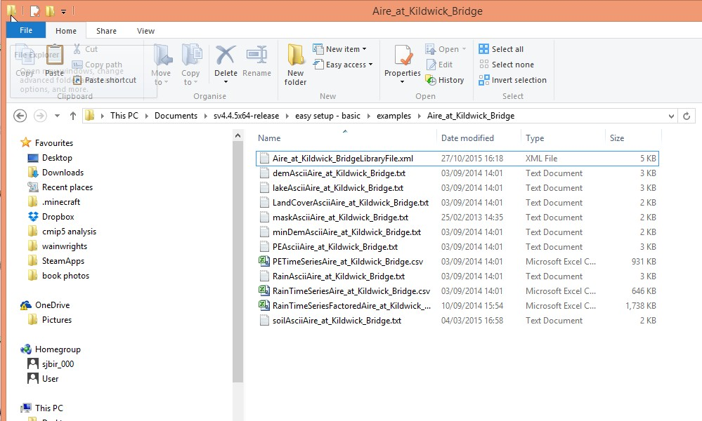

1. **Open xml(library) file in text editor (e.g. WordPad or NotePad)**

This contains links to the ASCII grid files and time series files and also parameter values

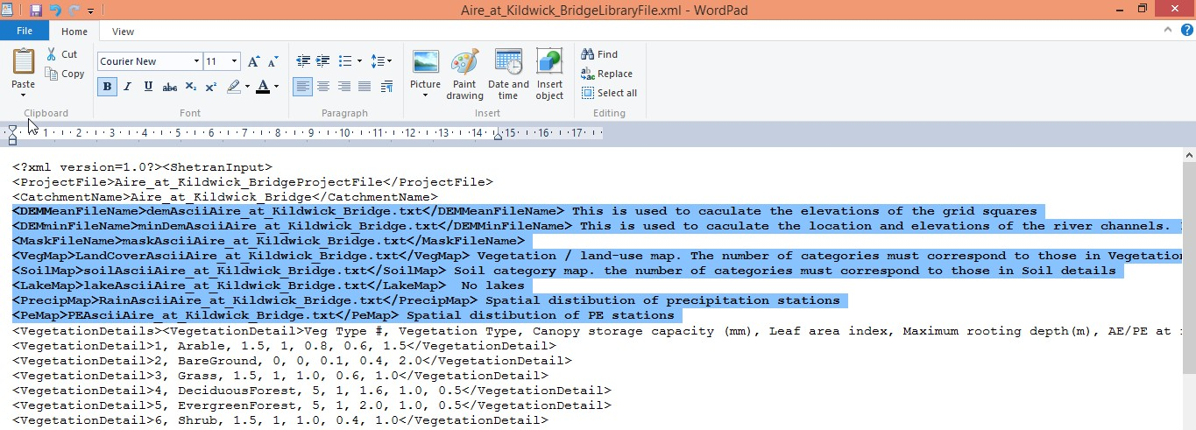

Highlighted are the seven ASCII grid files. These come from a GIS. The lake map is optional if there are no lakes type put nothing between the start and end tags: “<LakeMap></LakeMap> No lakes”

1. **Look at DEM ASCII grid**

ASCII grids are just text files from a GIS. Open Dem ASCII grid in the text editor. The catchment has 18 columns and 27 rows. All the grids must be the same. There are 6 header lines and then the data.

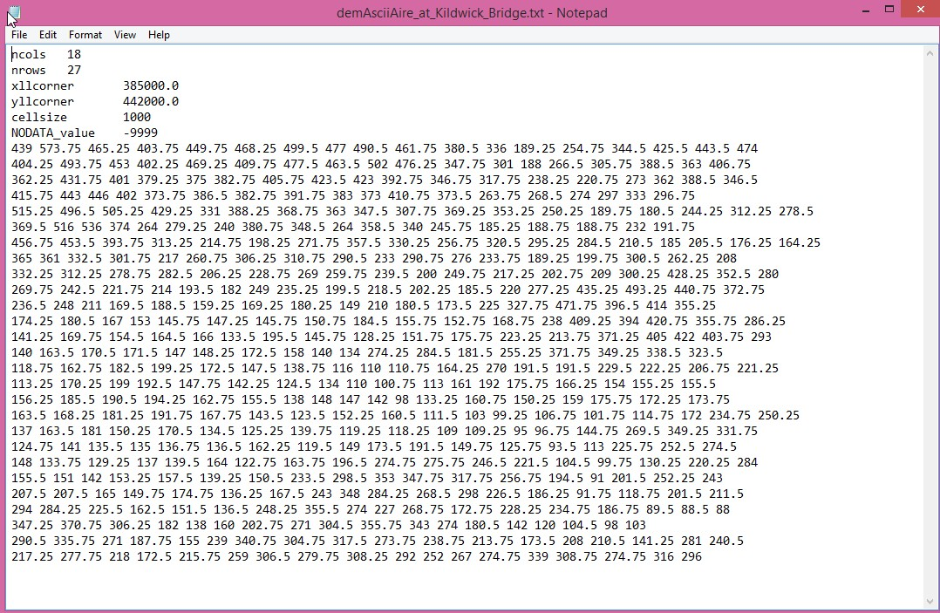

1. **Look at parameter values in the xml(library) file**

7 vegetation types are defined. The locations of each are in LandCoverAsciiAire_at_Kildwick_Bridge.txt.

Each vegetation types has the following parameters:

Canopy Storage capacity (mm)

Leaf area index

Maximum rooting depth (m)

Actual/potential evaporation at filed capacity

Strickler overland flow coefficient

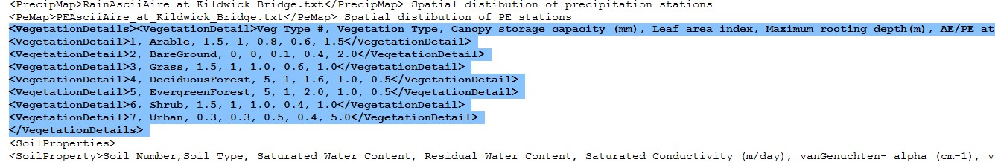

Four soil category types are defined. The locations of each are in soilAsciiAire_at_Kildwick_Bridge.txt.

Each category type is defined in SoilDetails. For example Category 3 has two soils. Soil 3 (defined in SoilProperties) to a depth of 1.2m and Soil 4 to a depth of 6.2m. Soil 3 is a medium Fine soil and soil 4 a highly productive aquifer. The SoilProperty parameters are:

Saturated water content (porosity)

Residual water content

Saturated conductivity (m/day)

vanGenuchten alpha (cm-1)

VanGenuchten n

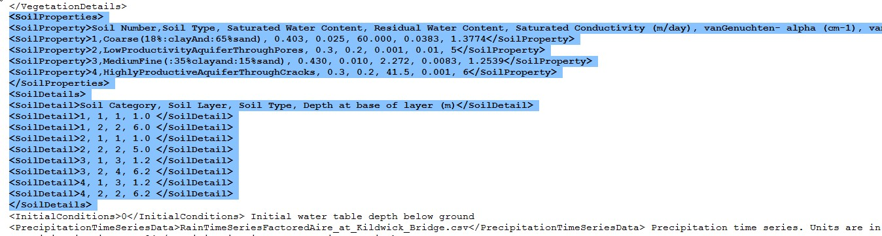

Initial conditions, links to time series files (including timestep) and start and end times of the simulation can also be seen.

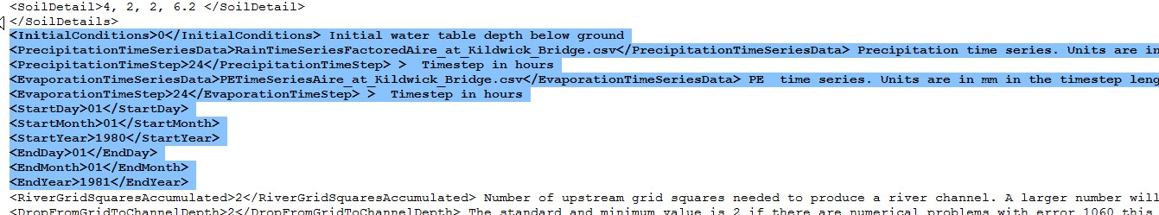

Other parameters values are defined at the end of the file.

1. **Run the Simulation**

Go to the program folder. There are 3 executables.

shetran-prepare.exe - This takes all the files in the example data set and produces the standard shetran input files. (e.g input_Aire_at_Kildwick_Bridge_frd.txt)

Shetran.exe – standard Shetran executable. Takes the standard input files (e.g input_Aire_at_Kildwick_Bridge_frd.txt) and produces the standard shetran output files (output_Aire_at_Kildwick_Bridge_pri.txt).

start.exe – runs both the above executables. First shetran-prepare.exe then Shetran.exe.

**To run simulation double click on start.exe and select “Aire_at_Kildwick_BridgeLibraryFile.xml” from the examples/Aire_at_Kildwick_Bridge folder**

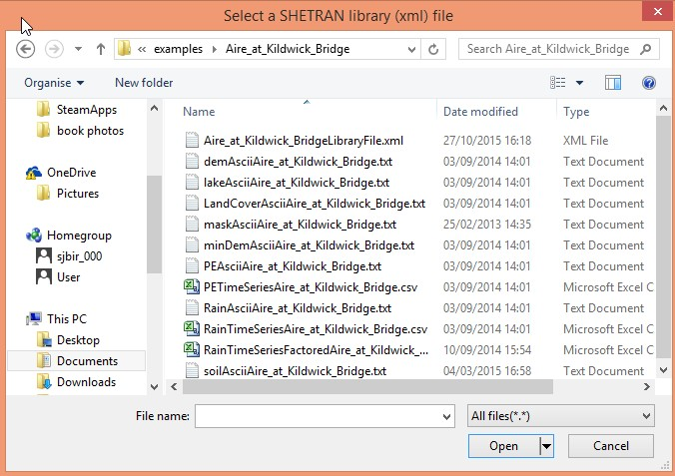

After a few minutes the simulation will finish

